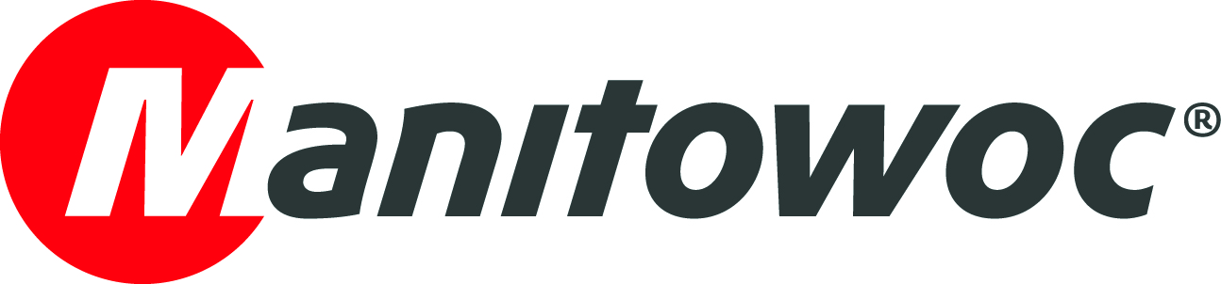
NEWS RELEASE

April 24, 2018

Manitowoc Cranes highlights innovation and velocity at Intermat Paris 2018

- Manitowoc has a sizeable presence at Intermat Paris 2018 in France, showcasing three tower cranes alongside a wide range of comprehensive support services.
- On display at the show are two great examples of Potain’s cutting-edge lifting advancements: the two Hup self-erecting cranes and an MDT 389, the largest of its CCS topless top-slewing tower cranes.

Manitowoc Cranes is showcasing some of its newest tower cranes and range of renowned support services at Intermat Paris 2018, which is taking place April 23 – 28, 2018 at the Paris-Nord Villepinte Exhibition Center in France. It is displaying two models from the Potain Hup self-erecting crane range – a Hup 32-27 and a Hup 40-30 – and a Potain MDT 389, the largest of its CCS topless top-slewing tower cranes. The company is located at booth #5B M 001.

Barry Pennypacker, president and CEO of Manitowoc, said the company’s exhibition at Intermat affirms that Manitowoc is delivering on two tenets of The Manitowoc Way: innovation and velocity. All of the cranes and new products on show were developed with customer input and participation. They reflect the technologies and features that the lifting market wants, and were developed with much more velocity to market than previous generations of cranes.

“Over the last two years, we have created a culture that is driven by innovation and velocity in every aspect of the business,” he said. “It involves not only maintaining our industry-leading innovation, but in a number of cases, accelerating it. I believe we have demonstrated this with our selection of products and services on display at Intermat. Our goal is to continue sharpening our focus on developing new products that deliver fundamentally more value to our customers and enhance our brand. This culture of innovation both strengthens our position and creates further opportunities for growth.”

Potain cranes on display
The Hup self-erecting crane range contains some of Potain’s most remarkable models of recent years. Since their launch in 2016, the Hup cranes’ versatility and ease-of-use have already made them an international hit. With the Hup range, customers can accomplish more tasks with a single crane. Their unique folding and unfolding design enables setup in the most congested job sites, and they offer a wide range of flexibility in working height, reach and footprint. In addition, they are some of the most operator-friendly tower cranes on the market, with an intuitive and ergonomic remote control for better operator productivity. Smart Set Up software also provides easy, safe and effective erecting and dismantling of the crane from the remote control.

The MDT 389 is the largest topless crane from the Potain lineup to feature the company’s Crane Control System (CCS), which is also available on all Potain top-slewing tower cranes. This user-friendly operating system offers owners the highest levels of comfort, flexibility and ergonomic control, and it reduces installation time compared to previous models. Its main benefits include compactness, ease-of-transportation, and easier and faster erection. All these features lead to a better return on investment for crane owners, and CCS has been proven to increase efficiency on the job site.

All-encompassing solution provider
Manitowoc’s booth also includes a host of displays and interactive exhibits related to a range of features and services, such as its Manitowoc Crane Care customer support program and Manitowoc Finance financing arm. Manitowoc aims to provide the lowest total cost of ownership in the industry, and through programs such as Crane Care and Lift Solutions, the company is decreasing downtime on the job site and assisting crane operators with unique lifting plans that many modern-day applications require.

Visitors can explore a host of cranes from across the Manitowoc ranges at the booth, including Grove mobile cranes and Manitowoc crawler cranes. Grove, in particular, is very prominent in Europe. Grove is an industry leader in the all-terrain, rough-terrain and truck-mounted crane market. The brand has achieved a number of firsts during its impressive history, including the world’s first slewing rough-terrain crane and the world’s first trapezoidal boom.

One of its newest hit models is the GMK4090 all-terrain crane, which comes in response to customer demand for lightweight, flexible taxi cranes in the 90 t capacity class. It has a narrow 2,55 m width, and its performance capabilities include the best taxi load charts in its class. It also features a five-section MEGAFORM boom design, a single-engine concept with a new Tier 4 final engine, CCS, MEGATRAK suspension and the TWIN-LOCK boom pinning system. The GMK4080-2, an 80 t version of the same crane, is also available to the global market (except for North America).

Also being highlighted on the booth is the just-released 300 t GMK6300L-1. The GMK6300L-1 continues the legacy of its predecessor, with several improvements made to the structural strength of the crane, improving load charts by over 7% on average when compared to the GMK6300L. At height, the improvements are even better, with advantages of over 16% in the boom length range of 70 m – 80 m. The new model will also feature Euromot 4/EPA Tier 4 final engines in the carrier and superstructure.

CCS enables these cranes to be fitted with MAXbase, Manitowoc’s outrigger positioning technology that enables them to be set in various configurations for added stability. This variable outrigger setting gives cranes more setup flexibility on job sites, especially when erecting them on irregular job site grounds, and also more capacity over the 360° standard load chart.

Other great examples of Grove’s leadership include the 100 t GRT8100 and 80 t GRT880 rough-terrain cranes. The GRT880 features a 41 m boom that is lighter than other cranes in its class. It’s more versatile than competitors’ cranes — it boasts up to 16% greater capacity at full radius, 13% greater capacity in mid-range applications and 27% greater capacity at close radii. As can be seen, Grove’s all-terrain and rough-terrain offerings are enabling lifting companies to bid for and win more jobs than ever before, all while using fewer cranes in their fleets.

“All of our recent advancements have been made possible by our Voice of the Customer (VOC) program,” Pennypacker explained. “VOC is about listening to customers’ needs and delivering products that consistently exceed expectations with quality, reliability and productivity, all while lowering total cost of ownership. We look forward to showing the results at this year’s Intermat.”

-END-

CONTACT
Cristelle Lacourt Oliver Halls
Manitowoc SE10
T +33 472 182 018 T +44 20 79 235 860
cristelle.lacourt@manitowoc.com oliver.halls@se10.com

ABOUT THE MANITOWOC COMPANY, INC.
Founded in 1902, The Manitowoc Company, Inc. is a leading global manufacturer of cranes and lifting solutions with manufacturing, distribution, and service facilities in 20 countries. Manitowoc is recognized as one of the premier innovators and providers of crawler cranes, tower cranes, and mobile cranes for the heavy construction industry, which are complemented by a slate of industry-leading aftermarket product support services. In 2017, Manitowoc’s net sales totaled $1.6 billion, with over half generated outside the United States.

THE MANITOWOC COMPANY, INC.
One Park Plaza – 11270 West Park Place – Suite 1000 – Milwaukee, WI 53224, USA
T +1 920 684 4410
www.manitowoc.com

